**SYNONYMS**

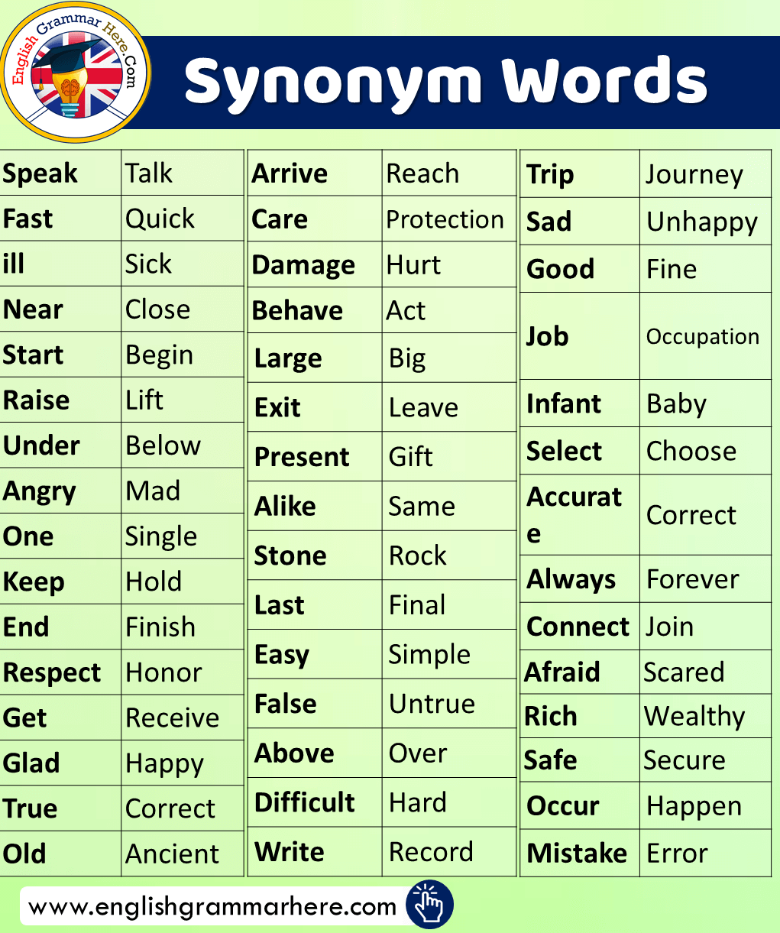

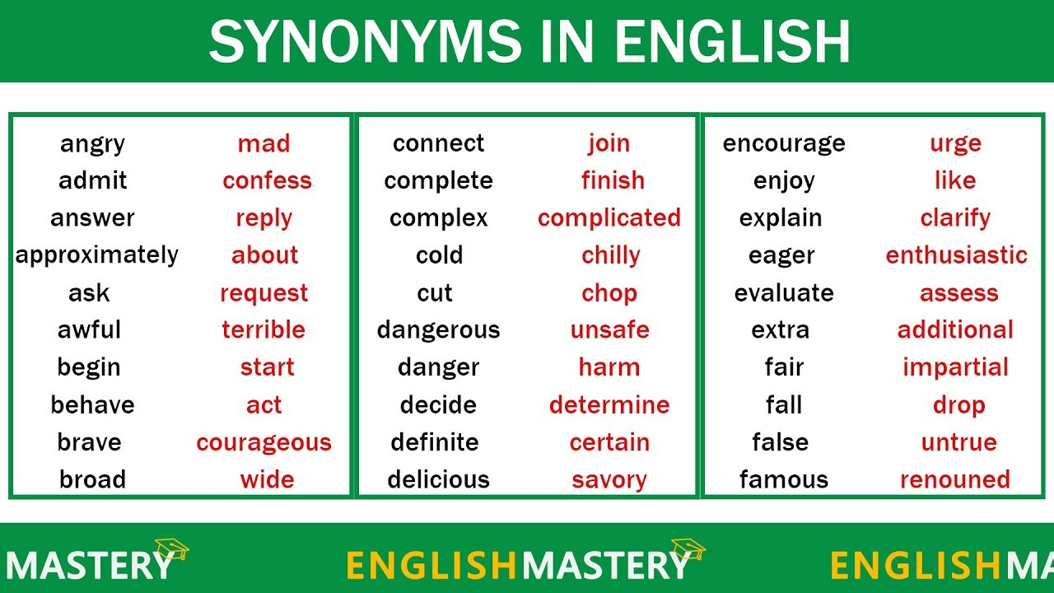

good looking – handsome untidy – messy wealthy – rich,

cry – shout – scream – yell look – stare – gaze – glance – glimpse

**ANTONYMS**

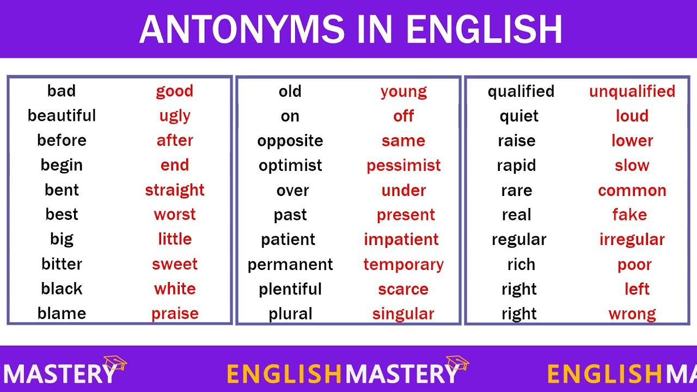

high – low tall – short poor – rich

thin – thick clever – stupid open – close

departure – arrival mean – generous disgusting – delicious

refuse – accept cheap-expensive common-rare

powerful-weak safe-dangerous useful-useless

**Exercises 1**

1. to begin → usually → terrible → missing → great → rubbish → couch → almost → to answer → away →

Choose the best synonym for each word.

absent, awful, fantastic, garbage, lost, nearly, normally, sofa, to reply, to start

**Exercises 2**

Find synonym for a word:

**kind** nice, wild, funny, best

**fast** quick, kind, heavy, small

**skinny** small, little, thin, strong

**angry** happy, mad, tired, sad

**cheap** poor, costly, pricey, inexensive

**nervous** short, direct, crazy, anxious

**many** a few, some, none, a lot

**produce** buy, make, sell, find

**mistake** mark, error, game, job

**occupation** job, man, see, do

**entire** (life) half, whole, most, part

**apart** (from)joined, separate, moving, together

**grateful** supportive, thankful, healthy, kind

**maybe** doubtfully, surely, perhaps, definitely

**warning** attention, emergency, victim, caution

**decline** mountain, discipline, hill, decrease

Kľúč: 2. nice, quick, thin, mad, inexpensive, anxious, a lot, make, error, whole, separate, thankful, perhaps, caution, decrease